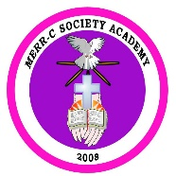MERR-C SOCIETY ACADEMY

Villa Rosalinda Compund 24 deAgosto St. Caingin, City of Malolos

Tel Nos. 796-1954 or 791-2768 E-mail: [merrc.society_acad@ymail.com](mailto:merrc.society_acad@ymail.com)

PHOTO

**ADMISSION FORM**

Name: Gender: Surname Given Name Middle Name

Address:

Birthday: Age: Place of Birth:

Religion: Citizenship:

Grade/Year level applying for: Name of School last attended:

Address of School last attended:

Father Mother

Name :

Address :

Tel No. :

Cel No. :

Occupation :

Office Adress :

Office No :

Name of Brothers/Sisters (according to age/ family position)

NAME GRADE/YEAR SCHOOL

In case of emergency, please notify Contact No.:

*I certify that the foregoing data are true and complete to the best of my knowledge.*

Signature over Printed Name (Parent/Guadian) Date

*Submit the following requirements:*

Xerox Copy of Birth Certificate Form 138-A Baptismal Certificate

Form 137/ Permanent Record 3 pcs. 2x2 pictures